Project Report

Online Medical Store

Sub-Topic : **Payment**

Abstract -

This project simulates the payment section of any online medical store where the other group members have worked separately for simulation of other sections of the medical store. These components can later be integrated into a fully functioning online medical store system where users can interact with the screen and buy medicine.

1) Introduction -

The payment of the medicines bought from the store is being facilitated in this mini project where a user can chose from 3 different ways to pay namely cash, card and UPI. A bill invoice is being generated at the end of successful payment which acts as a receipt for the user. Payment History can also be accessed from here by the admins to check and verify the payment and their sales.

2) Assumptions made -

* The user has already selected medicines they have to buy and a grand total amount was generated by Sales simulation of our group G4 (Here we are taking randomly generated total).
* The payment through cash initiates order and cash will be collected after the delivery.
* The UPI payment automatically initiates payment request to the entered UPI ID.
* The cash Method the sends a OTP which is being generated and stored in the local machine is sent to the phones of the user.

3)Components Used - SAP Server- LS4, SAP ABAP- Data Dictionary, Module Pool, Adobe Forms.

4) Name of the components made –

Package

Database Tables (for payment)

(for admin login)

Module Pool Program

Transaction ID

Adobe Form

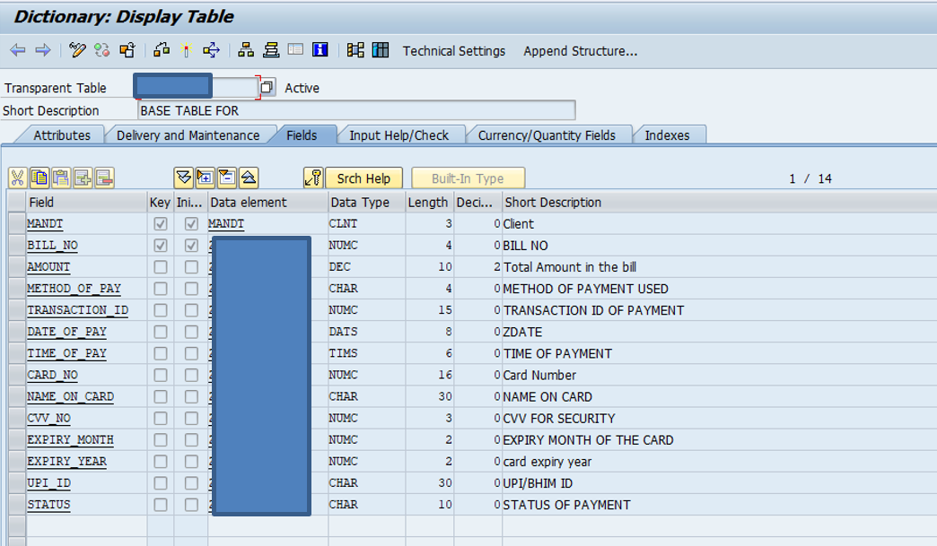

Figure 1. Payment Table

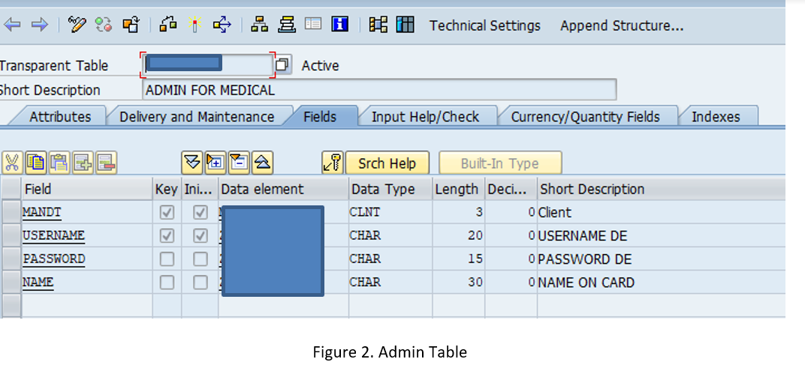

5) Functionalities -

* Payment using Cash.
* Payment using Card with randomly generating OTP which is being send to a flat file.
* Payment using UPI with timer (when timer reaches 0, the payment is failed).
* Admin Login.
* Payment History reports with ALV.

6) Working –

**Screen 1**- The user is first directed to a screen where his bill amount is shown and he can select between 3 methods to pay the bill, namely, by cash, card or UPI which is implemented using **Radio buttons.** There are 2 push buttons “proceed to buy” and “cancel” to trigger or cancel the payment respectively and there is another push button for “admin” which redirects him to a screen where he can login and see the payment history data produced by ALV’s.

The amount is generated here by calling the standard function “QF05_RANDOM_INTEGER”.

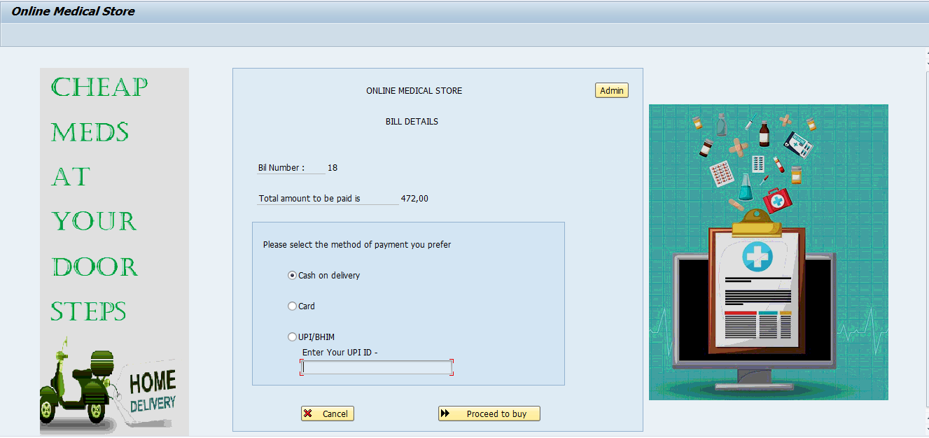

1. When Cash is selected and submitted – The order is automatically placed and the user will have to pay in cash when he receives the delivery.

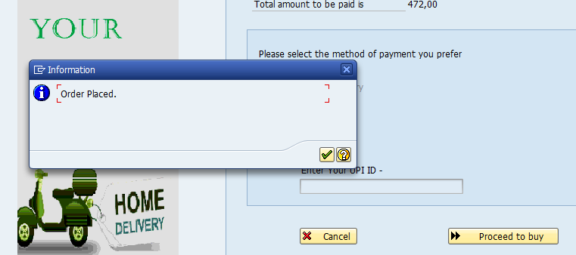

1. When Card is selected –

**Screen 2** is popped up where you have to enter your card details and press on push button “continue” for OTP verification. The other two push buttons back and exit takes you to screen 1 and cancels the payment respectively.

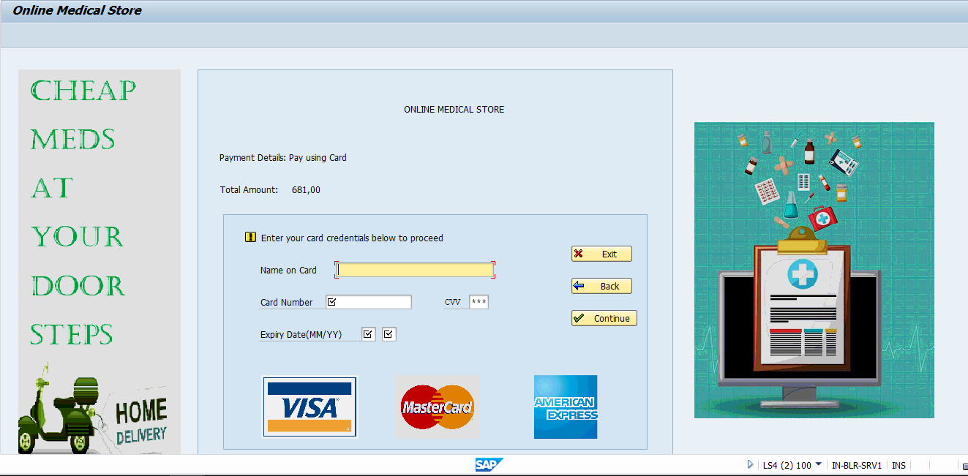

2.1) When Continue –

The OTP is randomly generated with the function “QF05_RANDOM_INTEGER” and being saved in the flat file in the desktop by using the function “GUI_DOWNLOAD” and the user will complete his payment only if that OTP is entered in the new Modal Dialog screen and presses continue.

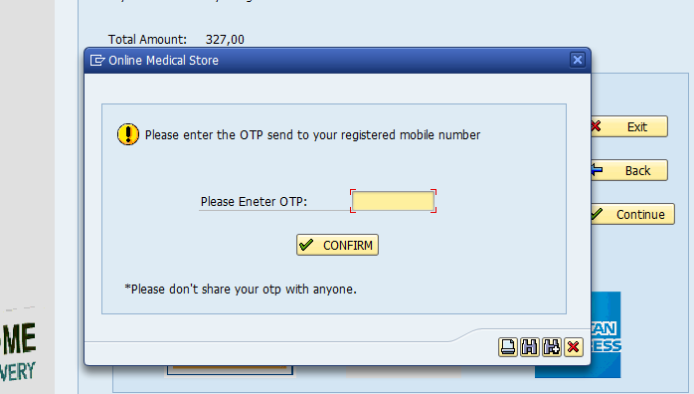

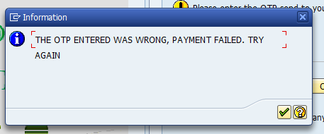

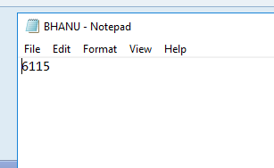

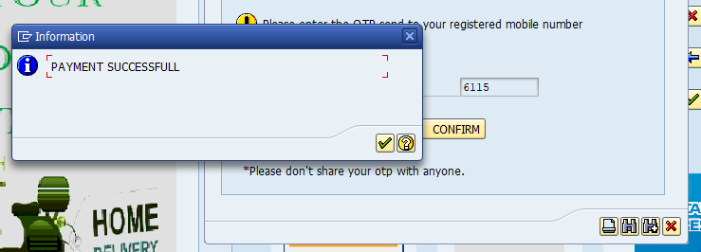

1. When UPI –

The UPI ID field which was hidden is unhidden and upon typing it and pressing “proceed to pay” a modal dialog window is opened with a timer inbuilt stating to complete the payment that has been requested to your UPI ID elapsing of which will terminate the payment. The timer is implanted using function “CL_GUI_CFW=>SET_NEW_OK_CODE” and decrementing the time variable.

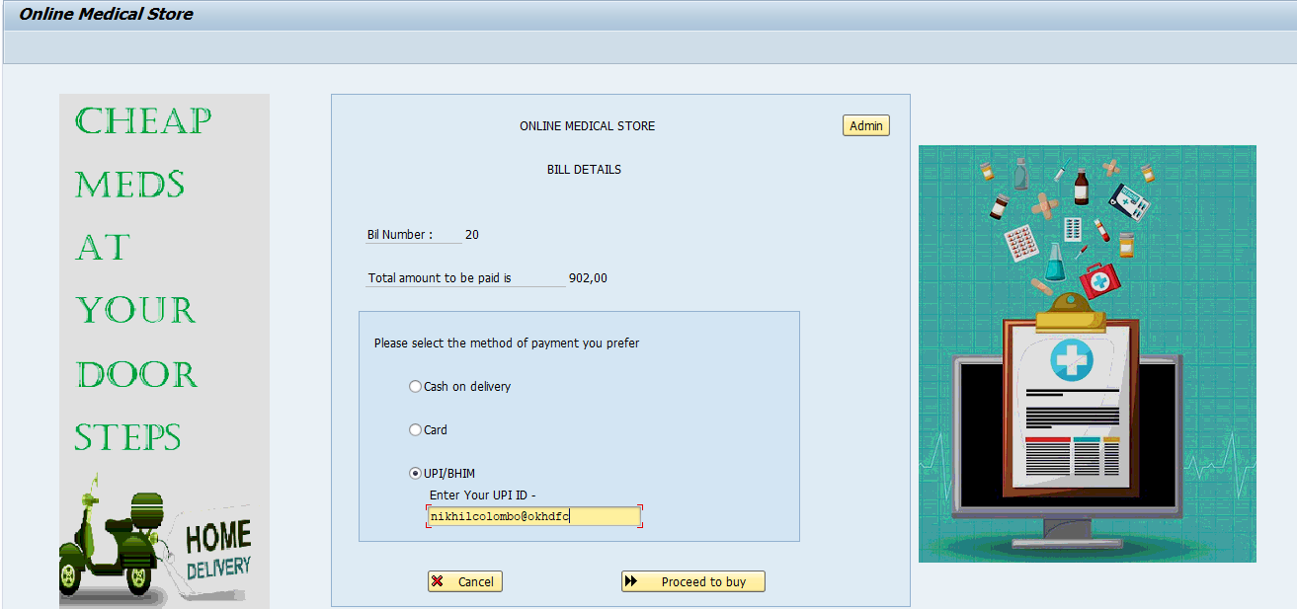

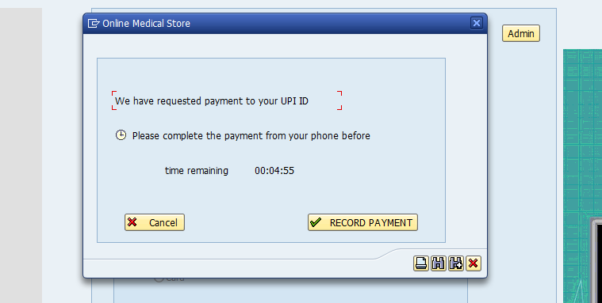

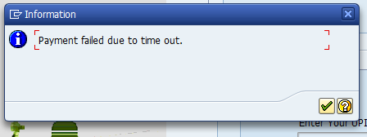

3.1) When Record Payment -

The Bill invoice generated by calling the adobe form after showing payment successful message.

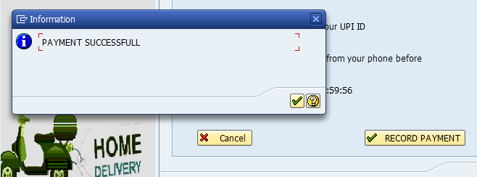

1. When Admin

The admin login screen is displayed where the username and password are checked from database to allow access to payment history reports created by ALV’s.

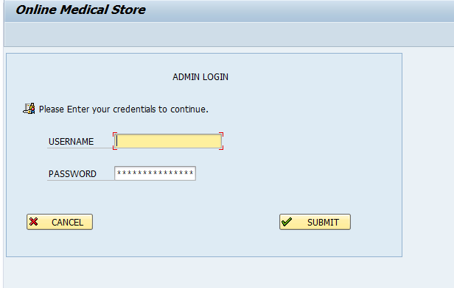

After The verification, Tabstrip is used to show three separate ALV’s based on the method of payment as the fields of every payment method is different.

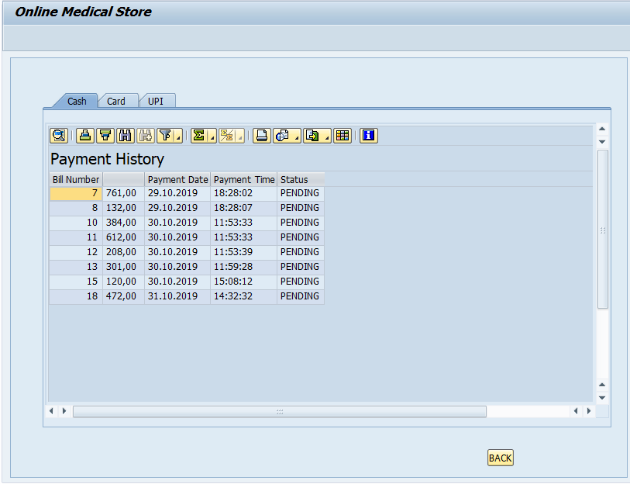

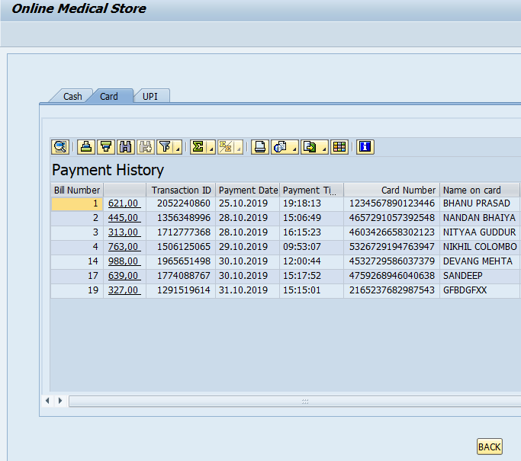

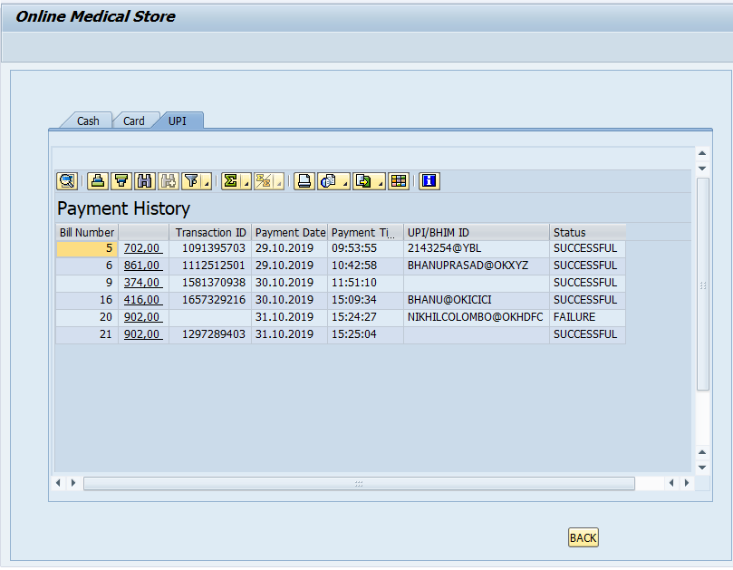

Adobe form to be integrated at the end of every successful payment –

